Release Notes
This hotfix is for D2C team to demo Metadata Creation / Targeting functions. The development is based on Userportal 8.0.6 patch.
Support new functions on User Portal:
- Create / Update Metadata
- Upload Movie / Preview / Images
- Target Title
Not Support:
- Customize Metadata Field for Creation / Updating
Currently, hard-coded mandatory / optional metadata fields for creation /updating.
- Get Associated Content Class / Provider from Current Login User
Currently, hard-coded content class as ‘Mediakind’, provider as ‘Mediakind’ when creating title metadata.

Metadata Create Page
- A new menu added in ‘Content’ menu list:
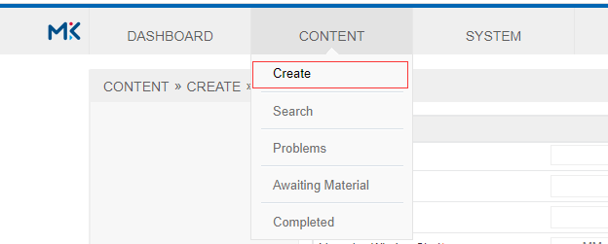

- Click ‘Create’ menu, a new page for creating metadata popup:
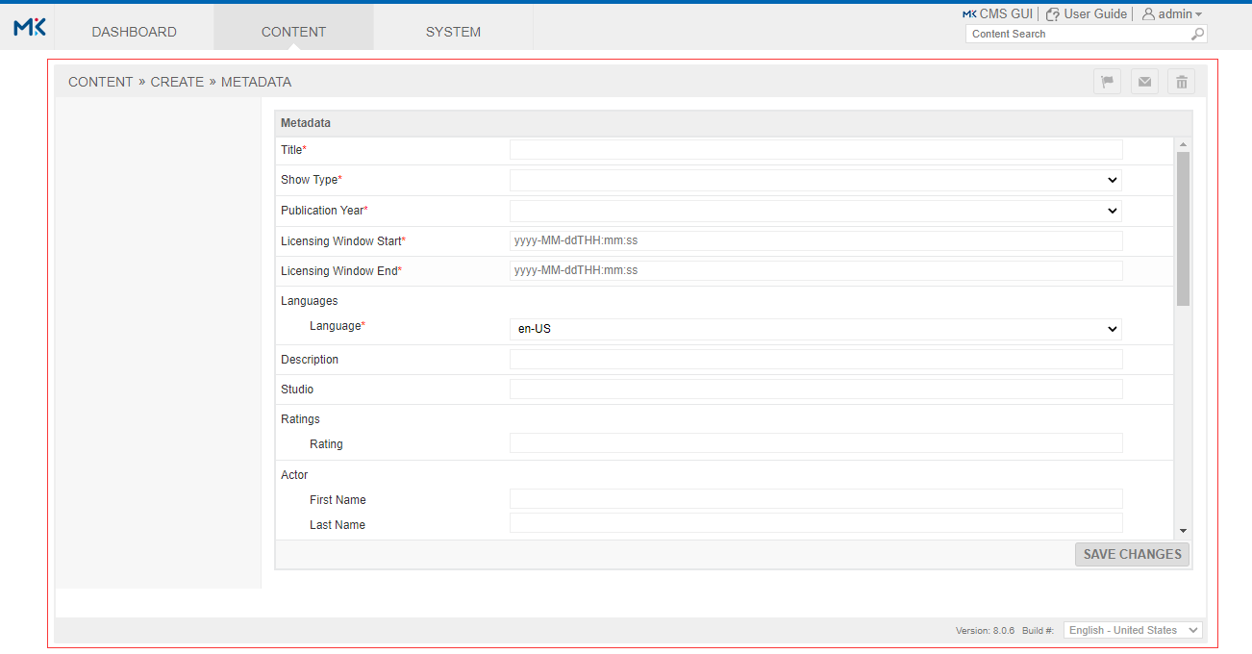
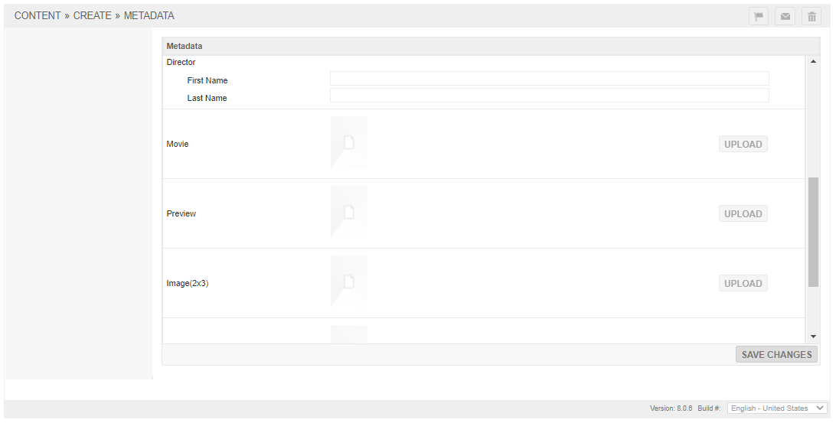
Notes:
  - The field name appended with * are mandatory fields, others are optional fields.
  - The ‘UPLOAD’ buttons are disabled on this creation page, not support upload file until saving the metadata changes.

Metadata Update Page
- After Click ‘SAVE CHANGES’ button on Create Metadata Page to save metadata, it will go to metadata update page:
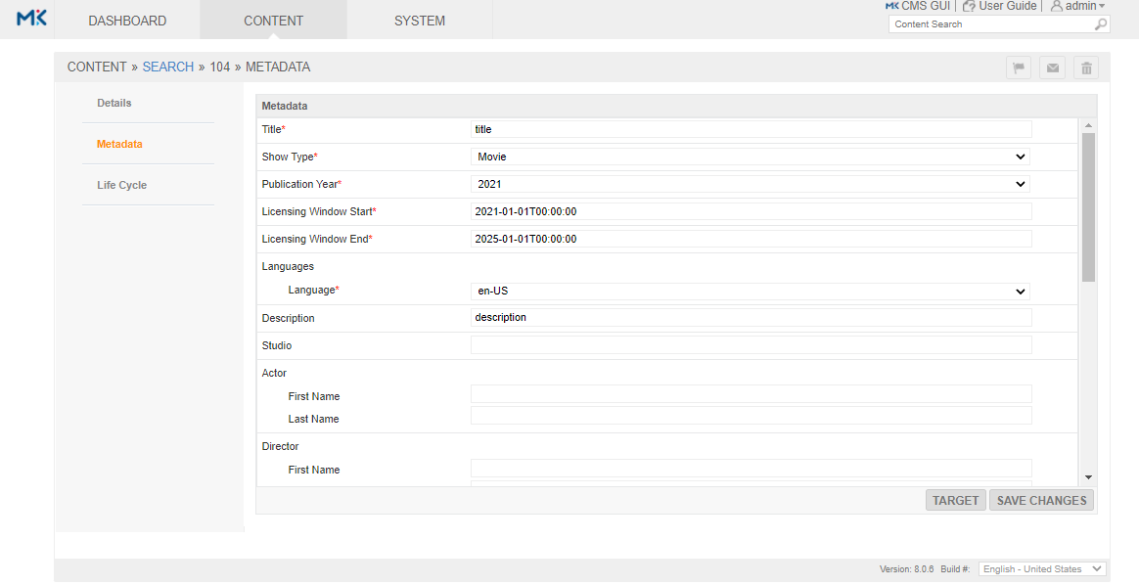
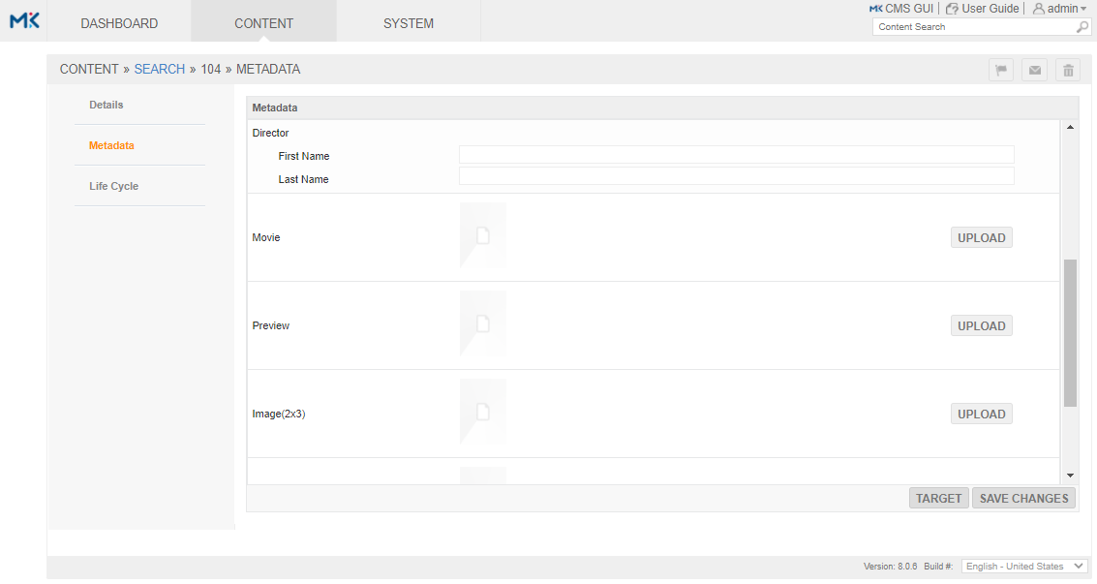
Notes:
  - The original ‘Assets’ page is removed, because the file upload function is integrated into this Metadata Update page.
  - In this Metadata Update page, we can update metadata files, and upload files (Movie / Preview / Images).
  - After metadata created or file uploaded, userportal will check if the title status become ready, if yes then send ingest event to cms to trigger content processing automatically.
  - After done content processing, we can trigger Targeting manually by click the ‘TARGET’ button on this Metadata Update page. It will trigger cms targeting rule to target to specific sites. So please make sure you have configured the targeting rule before trigger the targeting.

Installation
- MD5 cheksum of rpms:
9dc10da9260d9c9596bed0d2bfa2f8ce userportal-8.0.6.107-1.noarch.rpm
829d81c529f9c4749963cae0e0531e86 portal-support-8.0.000.102-1.noarch.rpm
- Install rpms:
  - Upload userportal-8.0.6.107-1.noarch.rpm to the /root folder on all PT nodes.
  - Upload portal-support-8.0.000.102-1.noarch.rpm to /root folder on all APP nodes.
  - Login to CS1 node, run below command to stop portaltomcat service on all PT nodes:
/etc/init.d/cms-cluster stop -s portaltomcat
  - Login to all PT nodes, run below command to install the userportal rpm:
yum install -y /root/userportal-8.0.6.107-1.noarch.rpm
  - Login to all APP nodes, run below command to install the portal-support rpm:
yum install -y /root/portal-support-8.0.000.102-1.noarch.rpm
  - Login to CS1 node, run below command to start portaltomcat service on all PT nodes:
/etc/init.d/cms-cluster start -s portaltomcat
- Manually merge Config.groovy after portal-support rpm installed:
  - Login to APP1 node, go to /opt/tandbergtv/cms/conf/portal/ folder, copy metadata group from Config.groovy.rpmnew file to overwrite the corresponding group in Config.groovy.
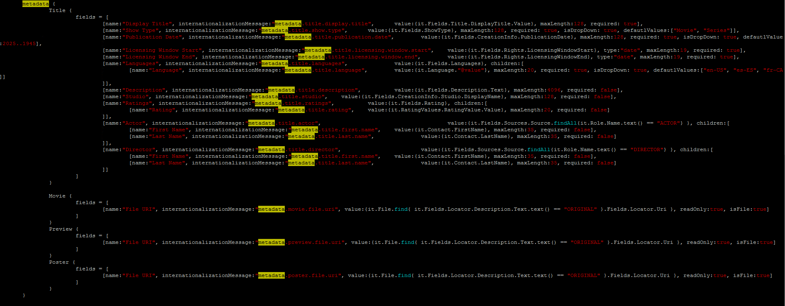

Rollback
- Rollback rpms:
  - Login to CS1 node, run below command to stop portaltomcat service on all PT nodes:
/etc/init.d/cms-cluster stop -s portaltomcat
  - Login to all PT nodes, run below command to rollback the userportal rpm:
yum downgrade -y userportal
  - Login to all APP nodes, run below command to rollback the portal-support rpm:
yum downgrade -y portal-support
  - Login to CS1 node, run below command to start portaltomcat service on all PT nodes:
/etc/init.d/cms-cluster start -s portaltomcat

